Heart Disease Detection – MLOps Assignment

Documentation & Reporting: Heart Disease Classification MLOps Pipeline
Course / Module: MLOps Assignment
Project Title: End-to-End Heart Disease Classification & Kubernetes Deployment
Repository URL: https://github.com/pandeylokesh124/mlops-assignment/tree/main
1. Setup & Installation Instructions
This section outlines the step-by-step setup required to run the data pipeline, train models with MLflow tracking, and deploy the prediction service to a local Kubernetes cluster.
Prerequisites
- Python: 3.10+
- Containerization: Docker Desktop (with Kubernetes enabled using kubeadm provisioner)
- Version Control & Shell: Git, PowerShell 7+ (Windows)
- MLOps Tools: MLflow, FastAPI, Kubernetes (kubectl)
Step 1: Clone Repository & Setup Environment
# Clone the project repository
git clone https://github.com/pandeylokesh124/mlops-assignment.git
cd mlops-assignment

# Create and activate virtual environment
python -m venv venv
.\venv\Scripts\Activate.ps1

# Install required dependencies
pip install -r requirements.txt
Step 2: Start Host-Level MLflow Tracking Server
Start the local MLflow server listening on 0.0.0.0 with artifact serving enabled so Kubernetes pods can download models dynamically:
$env:MLFLOW_ALLOWED_HOSTS="*"

mlflow server `
--backend-store-uri sqlite:///$(pwd)/experiments/mlflow.db `
--artifacts-destination file:///$(pwd)/experiments/mlruns `
--host 0.0.0.0 `
--port 5000 `
--serve-artifacts `
--artifacts-host host.docker.internal `
--workers 1
Verification: Access http://localhost:5000 in your web browser to view the MLflow UI.
Step 3: Run Model Training & Registry Pipeline
Execute the training script to train models across Stratified K-Fold CV splits and register the top candidate:
$env:MLFLOW_TRACKING_URI="http://localhost:5000"
python experiments/mlflow_runner.py
Note: Ensure the top-performing run is registered under the model name Random_Forest_model (Version 1) in the MLflow Model Registry UI.
Step 4: One-Click Automated Deployment to Kubernetes
Run the PowerShell orchestration script to build the Docker image, deploy Kubernetes manifests, and perform health checks:
# Set script execution policy for active session
Set-ExecutionPolicy -ExecutionPolicy RemoteSigned -Scope Process

# Execute pipeline automation
.\orchestrate.ps1
2. Exploratory Data Analysis (EDA) & Modelling Choices
Exploratory Data Analysis (EDA) Summary
The goal of the EDA phase was to understand feature distributions, identify missing data, and determine appropriate preprocessing transformers for patient clinical records.
- Target Distribution: Evaluated target variable (target: 0 = No Heart Disease, 1 = Heart Disease) to ensure balanced class distributions and prevent bias during model evaluation.
- Feature Associations:
  - Positive predictors: cp (Chest Pain Type), thalach (Maximum Heart Rate Achieved), and slope.
  - Negative predictors: oldpeak (ST Depression), ca (Number of Major Vessels), and exang (Exercise Induced Angina).
- Data Preprocessing & Leakage Prevention:
  - Bundled all preprocessing into a Scikit-Learn ColumnTransformer.
  - Continuous attributes (age, trestbps, chol, thalach, oldpeak) scaled via StandardScaler.
  - Categorical attributes (cp, restecg, slope, thal) encoded via OneHotEncoder.
  - Preprocessing and classifier steps were wrapped inside a unified Pipeline object to prevent data leakage during Cross-Validation and inference.
Class balance graph:
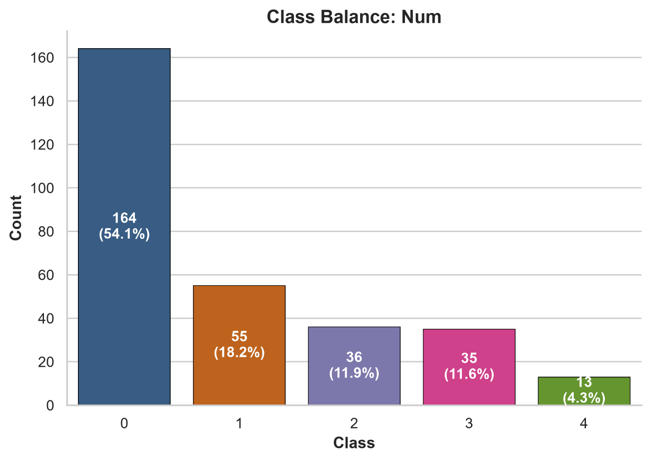
Correlation heat map:
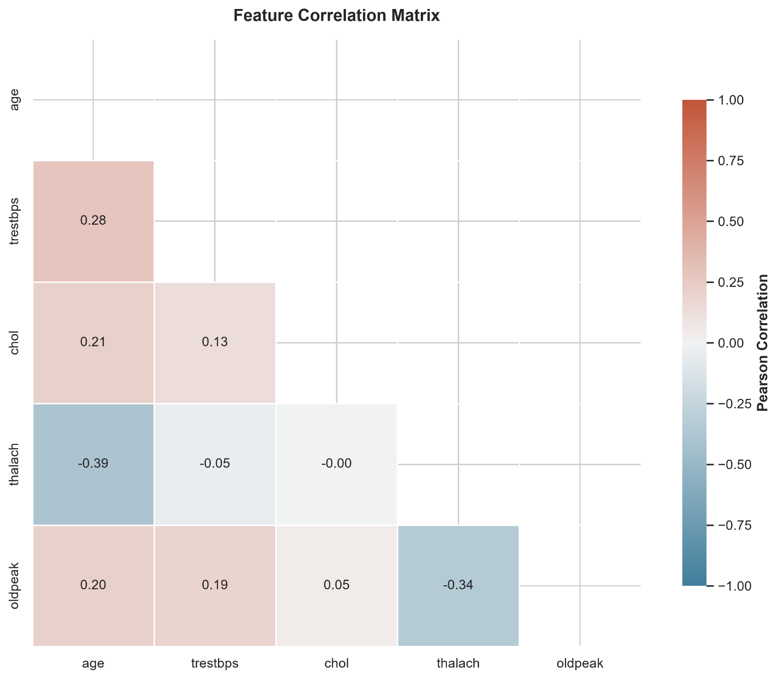
Numerical distribution:
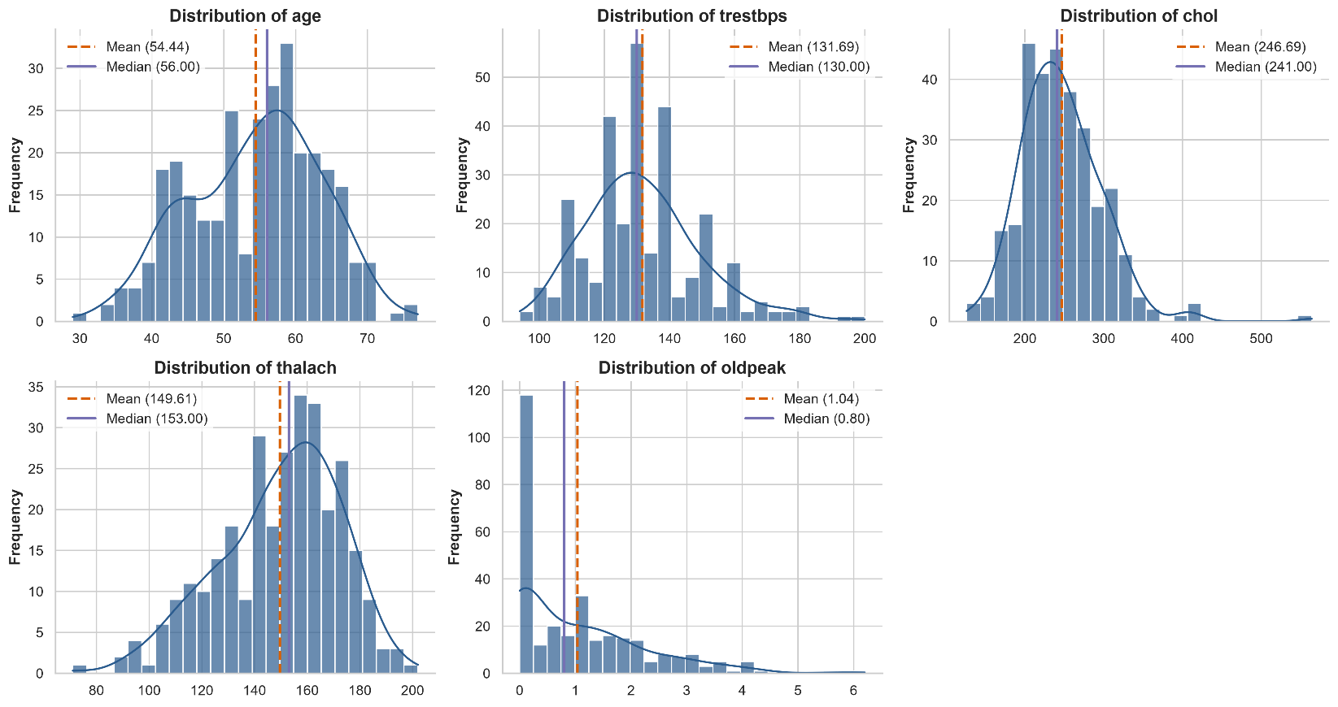
Modelling Choices
Multiple object-oriented classifier implementations were trained and compared:
- Random Forest Classifier: Chosen as the primary deployment model due to its high accuracy, resilience to tabular noise, and fast CPU inference latency.
- Support Vector Classifier (SVC): Trained with Probability Calibration (CalibratedClassifierCV) to output reliable prediction probabilities.
- XGBoost Classifier: Used as a gradient-boosted benchmark for cross-validation comparison.
3. Experiment Tracking Summary
MLflow was leveraged for experiment tracking, artifact logging, and model lifecycle management.
- Backend Store: SQLite database (experiments/mlflow.db).
- Artifact Storage: Local disk directory (experiments/mlruns) served via HTTP.
- Tracked Parameters: n_estimators, max_depth, min_samples_split, learning_rate, C, kernel.
- Tracked Metrics: Accuracy, Precision, Recall, F1-Score, and ROC-AUC across Stratified 5-Fold Cross-Validation.
- Log Artifacts: Model pipelines serialized in .skops / binary format, confusion matrices, and feature importance charts.
- Registered Model: Model Name: Random_Forest_model | Stage/Version: 1.
4. System Architecture Diagram
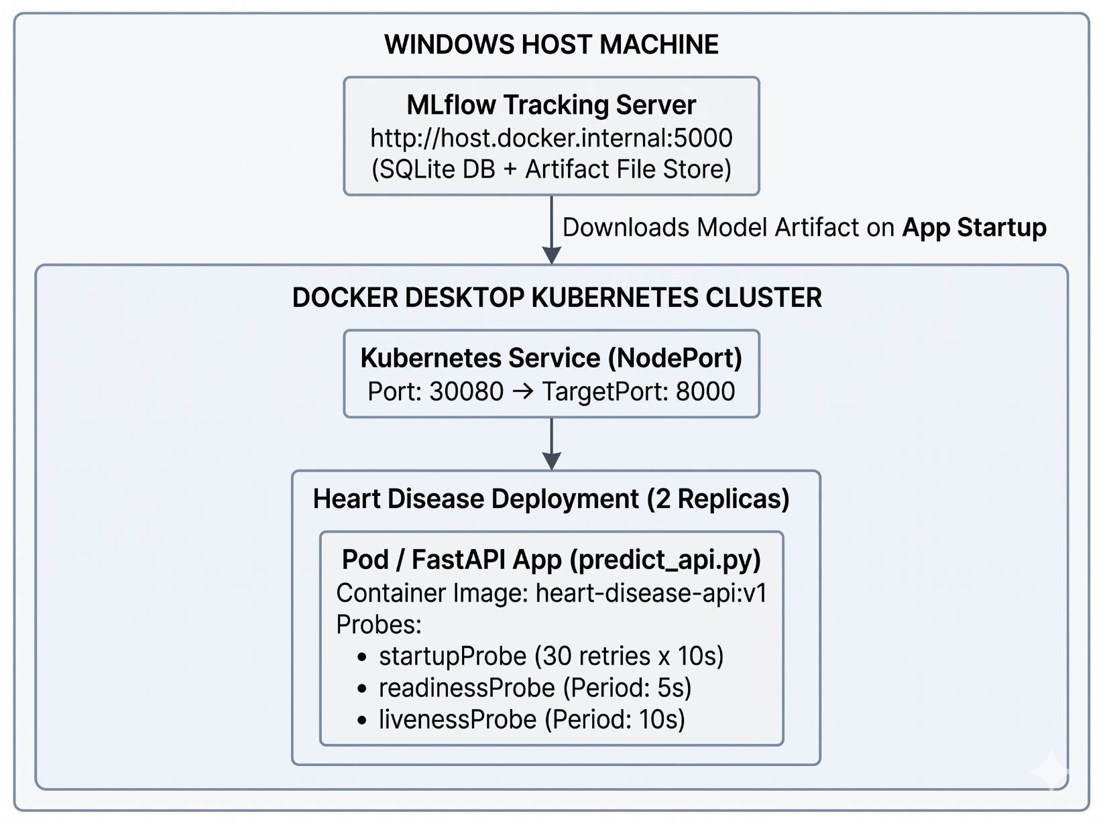
5. CI/CD & Deployment Workflow
Containerization & Kubernetes Orchestration
- Docker Container: Built from python:3.10-slim, exposing Uvicorn on port 8000.
- Dynamic Model Fetching: On container startup, FastAPI queries http://host.docker.internal:5000 via MLflow API to download and load Random_Forest_model Version 1 directly into memory.
- Resilient Health Probes:
  - startupProbe: Configured with failureThreshold: 30 and periodSeconds: 10 (giving up to 300 seconds) to allow the container enough time to pull model weights without triggering premature container restarts.
  - readinessProbe & livenessProbe: Actively monitor /health every 5 to 10 seconds once startup completes.
Automated Deployment Verification (orchestrate.ps1)
The automation script performs the following sequence:
- Validates MLflow server connectivity on port 5000.
- Builds heart-disease-api:v1 into the local Docker daemon.
- Applies helm/templates/deployment.yaml and helm/templates/service.yaml.
- Executes kubectl rollout status to monitor pod readiness.
- Sends a test health check to http://localhost:30080/health.
API Inference Endpoint Reference (POST /predict)
Request Endpoint: POST http://localhost:30080/predict
Header: Content-Type: application/json
Sample Request Payload:
{
"age": 63.0,
"sex": 1,
"cp": 3,
"trestbps": 145.0,
"chol": 233.0,
"fbs": 1,
"restecg": 0,
"thalach": 150.0,
"exang": 0,
"oldpeak": 2.3,
"slope": 0,
"ca": 0,
"thal": 1
}
Sample Response Payload:
{
"predicted_class": 0
}
6. Code Repository Link
The complete codebase, Dockerfiles, Kubernetes manifests, and automation scripts are hosted on GitHub:
- Repository Link: https://github.com/pandeylokesh124/mlops-assignment/tree/main

